CSC 4880 – Artificial Intelligence

Directions: You do not need to turn in this homework. It is meant as a study guide for questions that will appear in the quiz, possibly with different phrasings, prompt formats or different trees. For all images displaying trees or graphs, you are welcome to request an adjacency list, weights and heuristic values.

Uninformed Search and Informed Search

Name one advantage of BFS over DFS, and one advantage of DFS over BFS in tree-like search problems

What advantages of BFS and DFS does iterative deepening combine in tree-like problems? Why is the overhead of iterative deepening typically restricted to a small constant factor? Does the relative overhead increase or decrease as the branching factor increases?

What data structure is typically used to implement the fringe in DFS, BFS, greedy best-first search, Dijkstra’s algorithm and A*?

If Dijkstra’s, greedy and A* are implemented with a min heap, what function does each algorithm use as priority?

In the graph seen at Figure 1, list the order in which nodes would be removed from the fringe (expanded) in greedy best-first search, Djikstra’s algorithm and A*. Break ties alphabetically, starting from A and reaching goal node G. If the algorithm finds a lower-cost path to a vertex currently in the fringe, update corresponding node’s priority (if needed) and parent rather than adding a duplicate to the fringe.

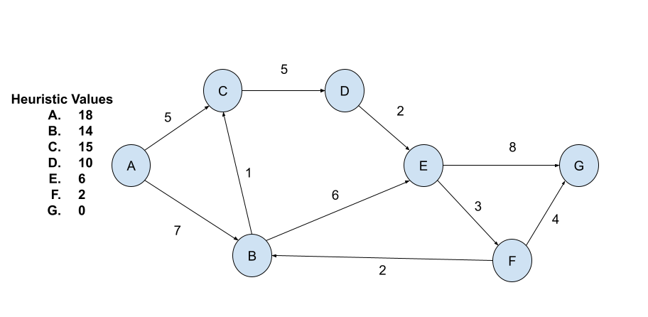
Figure 1 - Directed graph with weighted edges and vertex heuristics.

Let $d^{*}(v)$ represent the cost of the optimal (lowest-cost) path from $v$ to any reachable goal in a directed graph. If no goal is reachable, by convention $d^{*}\left(v\right)=∞$. Check the correct option: A heuristic is $h$ admissible if, for all vertices

$h\left(v\right)≤d^{*}(v)$, that is, $h$ never overestimates the true optimal cost

$h\left(v\right)≥d^{*}(v)$, that is, $h$ never underestimates the true optimal cost

Given the in Figure 2, where nodes I and F are considered goal nodes, edit the heuristic value of a single node (alternatively: the cost of a single edge) so that the heuristic becomes inadmissible and such that if A* returns the path to the first goal node expanded (removed from the fringe) it fails to find the optimal path.

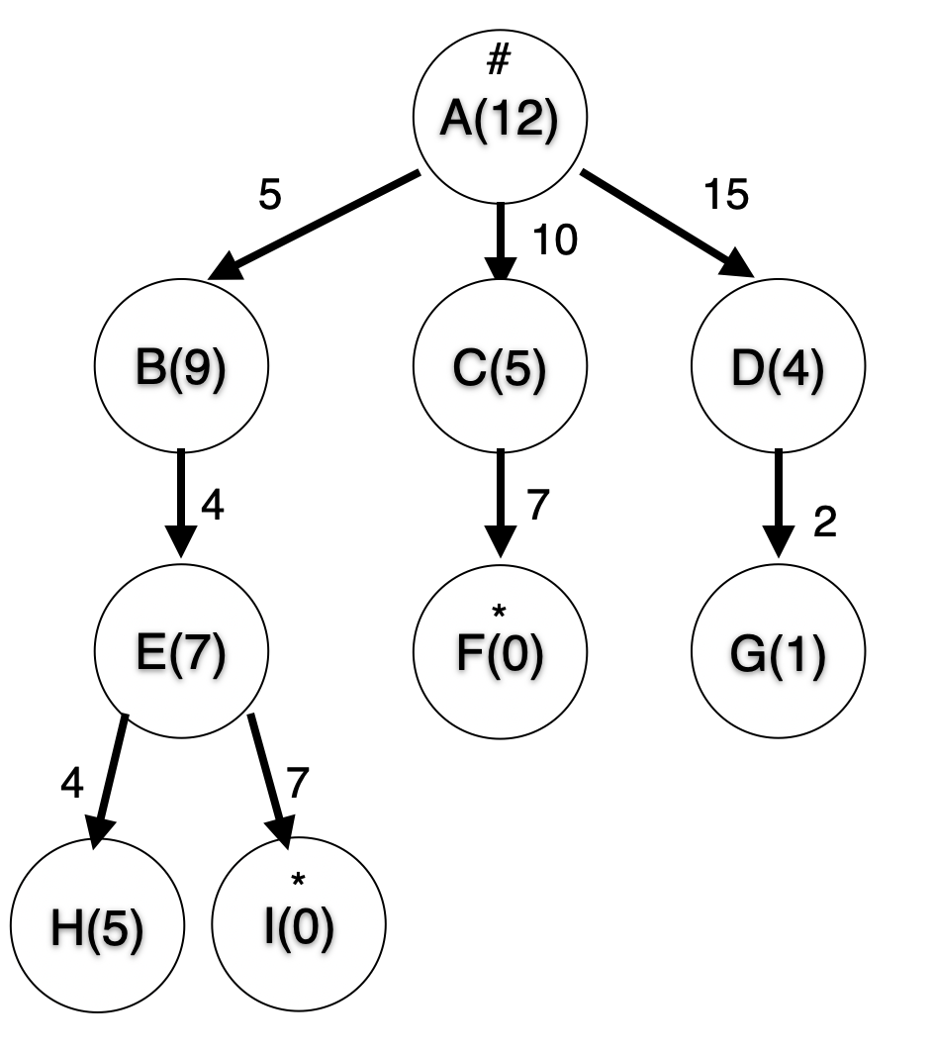
Figure 2 - Tree with edge costs and vertex heuristics

Minimax and Alpha-Beta Pruning

For all questions in this section, you may may assume that the game tree is finite and that it can be fully explored with the available computational resources, and that no heuristic cutoff takes place.

Suppose all players in a game implement Minimax as seen in class and chose the action corresponding to the successor with best Minimax value. Which of the following options describe assumptions about the problem under which this set of strategies form a Nash equilibrium?
( ) Single agent | ( ) Deterministic | ( ) Admissible Heuristic | ( ) Alternating turns
( ) Two agents | ( ) Non Deterministic | ( ) Fully observable | ( ) Continuous time
( ) Three or more agents | ( ) Low branching factor | ( ) Hidden information | ( ) Zero-Sum

Suppose you could visit the successors of a MAX node either in decreasing (largest first) order of minimax value or increasing (lowest first). Which would likely result in more nodes being pruned by alpha-beta pruning?

True or False? The value of the root as calculated by Alpha-Beta Pruning is the same as the one calculated by Minimax.

For the game tree given in Figure 2 - Minimax Search Tree, use minimax with no pruning to calculate the value of each internal node. State a sequence of actions both players could take if playing optimally.

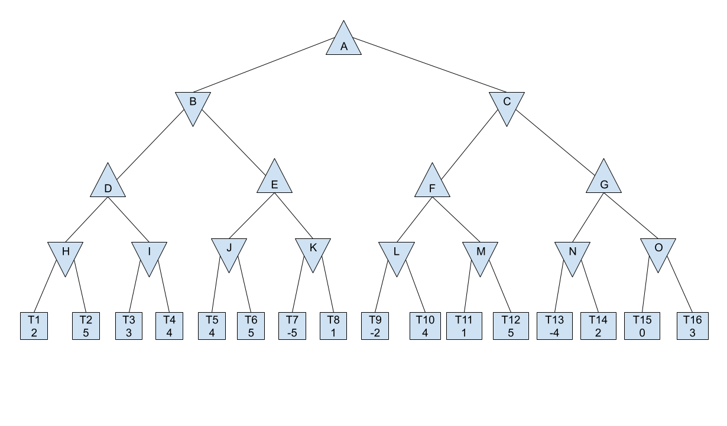
Figure 3 - Minimax Search Tree

In Figure 2 - Minimax Search Tree, use alpha-beta pruning to calculate the value of each internal node that is not pruned. List the roots of the pruned subtrees. State a sequence of actions both players could take if playing optimally.

Modify the value of up to two terminal nodes in Figure 2 - Minimax Search Tree such that, when expanding neighbors left to right:

T4 can be pruned after visiting T3

The subtree rooted at K can no longer be pruned under the same traversal order.

Appendices

Heuristic values and edge weights for the graph shown in Figure 1

Vertex | Heuristic |  | Edge | Weigh
A | 18 |  | (A,B) | 7
B | 14 |  | (A,C) | 5
C | 15 |  | (B,C) | 1
D | 10 |  | (B,E) | 6
E | 6 |  | (C,D) | 5
F | 2 |  | (D,E) | 2
G | 0 |  | (E,F) | 3
 |  |  | (E,G) | 8
 |  |  | (F,B) | 2
 |  |  | (F,G) | 4

